**System administrator's guide chat-bot.**

**Install and migrate the code.**

The program code was posted on the website www.pythonanywhere.com however, you can use another web hosting. If you are using pythonanywhere, you must register on this hosting and then create a new application in the Web section.

In the Consoles section, run the bash console and execute the command:

$ pip install -r requirements.txt

This file stores all the libraries on which the project depends, with version numbers.

Next, you need to transfer the source code from The github repository by typing in the console:

your_dir> git clone [https://github.com/iLizardKing/flask-school-chatbot.git](https://vk.com/away.php?to=https%3A%2F%2Fgithub.com%2FiLizardKing%2Fflask-school-chatbot.git&cc_key=)

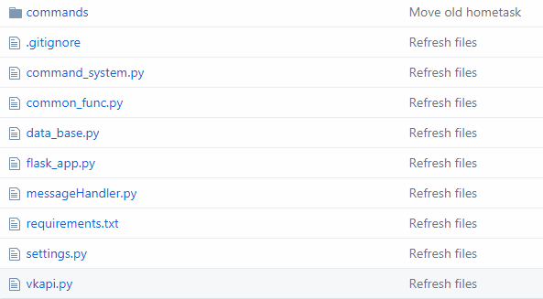

**Receiving the API token "Vkontakte".**

In your group (If it is not – create) in the "community Management" select "work with API". Create an access key by allowing the app to access community messages. Next, in the "Callback API" tab, look at the line that the server should return.

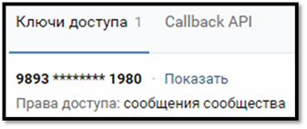

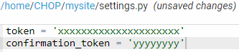In file settings.py change the xxx value in token = ' xxx ' to the access key you received. In confirmation_token = 'yyy', instead of yyy, write a string that should be returned by the server.

**GitHub Branches:**

*chop* is a fully working program.

*10soc-eco -* branch with the latest updates of the program code, as well as with interesting innovations.

*master -* branch with the working program of the old version.

**Custom settings:**

**В common_func.py**

*datetime_now* - you can set the time zone, the default time is Moscow time (+3 UTC).

*translite –* you can change the automatic conversion from English to Russian and vice versa to another language.

**messageHandler.py**

*damerau_levenshtein_distance* - you can change the percentage of error recognition, etc.

*get_answer* – message that is displayed if the required command could not be recognized.

*load_modules* – it's important to see that there is a name for your_directory / folder_where_secured_list_commands (Example mysite / command), if you created not as in the proposed version (In the 10soc-eco branch, the program automatically determines the path to the files).

**data_base.py**

You are offered an approximate view of the database. TIMETABLE - the schedule of calls, SCHEDULE - the schedule of lessons.

**In the folder where the files are stored (Example hometask.py):**

*message* – the message text to be displayed to the user

The *attachment* contains a video, audio, photo file in the format attachment = 'zzzz-xxxxx_xxxxx' ('photo-xxxxx_xxxxx')

In *hometask_command.keys* - the keyword that appears when you enter the "help" command, and when you enter it, the necessary message will be displayed.

In *hometask_command.description* - the description of the command.

**Possible problems and solutions:**

**Problem.** No library or module is installed in pythonanywhere.

**Decision.** When installing libraries or modules on this site, you need to write -user after $ pip install, and then enter the name of the library or module that you want to install (Example: $ pip install --user vk)

**Problem.** The bot does not send a photo, video, audio, document from the group.

**Decision.** The template for sending files is represented as attachment = 'zzzz-xxxxx_xxxxx', where photo, video or audios is written instead of zzzz, and the file number instead of xxxxx_xxxxx is the file number, but if you upload a file from the group, you must put "-" (before the file number) Minus sign) (Example: photo-116616497_456239066).

**Problem.** After 3 months, the program stopped working on pythonanywhere.

**Decision.** Pythonanywhere provides an opportunity to use its functions for free. However, every 3 months you need to confirm the work on the site by clicking the RUN button in the Web tab. Attention! About the soonest suspension of the work of your program on the site you are informed in a week by e-mail so that you can continue to work on the site in advance. Another solution is to buy an improved version of the account in case you do not have the opportunity to continue working every 3 months.

**Problem.** No libraries are installed via $ pip install -r requirements.txt

**Decision.** This problem can arise because of the conflict between the installed versions of the libraries. This happens if you previously installed these libraries of a different version. The solution is to install PYTHONPATH, followed by installing the package via pip -t Another solution is the manual installation of libraries

$ pip install Flask (If Flask is not installed immediately)

$ pip install --user vk

**Problem.** The program gives an error!

**Decision.** First, look at the last file that you worked in, pythonanywhere will indicate an error. If the error is not found, in the WEB tab in the Log files, select Error log. There you will be described in detail a list of all the errors and their location in the program code. If the error is not found, you can contact the developer.



**Developer contacts.**

**Email** – rikimust@gmail.com

**Telegram** – https://telegram.me/rikimust

**VKontakte** – https://vk.com/rikimust

**Github** – https://github.com/AlexCris GitHub Repository

**User guide**

a) Decide on the choice of social network - VKontakte or Telegram.

b) Choose how you want to enter the social network - a mobile application or a web version.

c) Sign in to your account.

d) In the search to find and join the channel or group of your class.

e) Write any word in the community message in "VKontakte" or write "/ start" in "Telegram".

f) Enter the required command using the proposed list.